**ACTIVIDAD INTEGRADORA 2:**

**Control Escolar**

BASE DE DATOS EN PHPMYADMIN

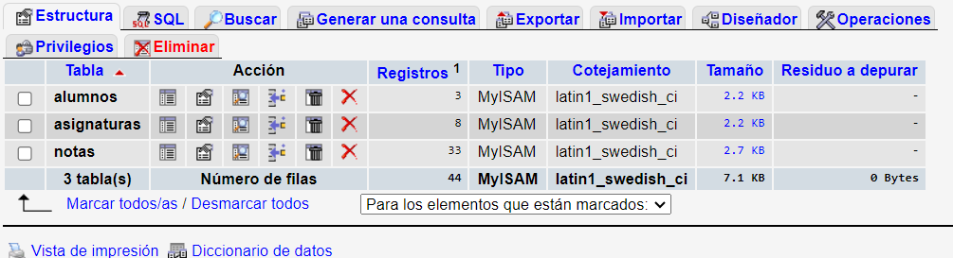

DISEÑO FÍSICO

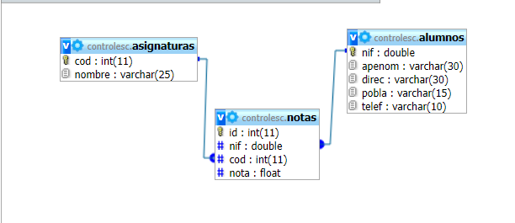

DISEÑO LOGICO

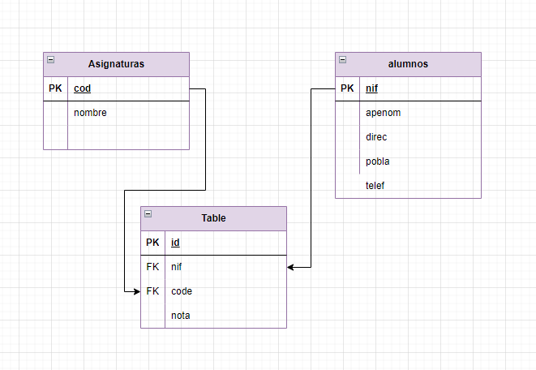

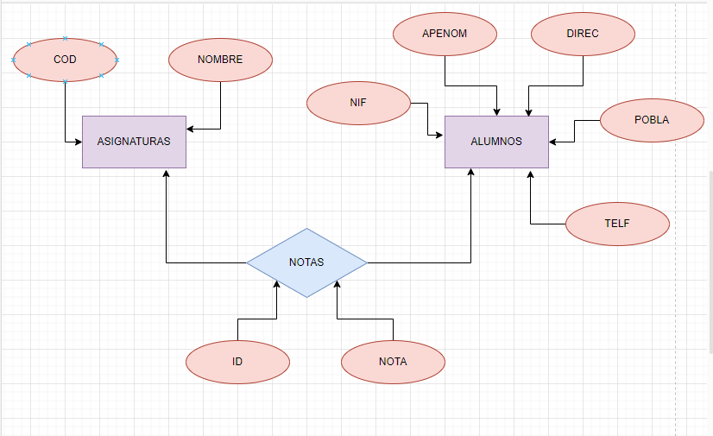DISEÑO CONCEPTUAL

SQL

-- phpMyAdmin SQL Dump

-- version 3.2.4

-- http://www.phpmyadmin.net

--

-- Servidor: localhost

-- Tiempo de generación: 25-08-2023 a las 10:46:03

-- Versión del servidor: 5.1.41

-- Versión de PHP: 5.3.1

SET SQL_MODE="NO_AUTO_VALUE_ON_ZERO";

/*!40101 SET @OLD_CHARACTER_SET_CLIENT=@@CHARACTER_SET_CLIENT */;

/*!40101 SET @OLD_CHARACTER_SET_RESULTS=@@CHARACTER_SET_RESULTS */;

/*!40101 SET @OLD_COLLATION_CONNECTION=@@COLLATION_CONNECTION */;

/*!40101 SET NAMES utf8 */;

--

-- Base de datos: `controlesc`

--

-- --------------------------------------------------------

--

-- Estructura de tabla para la tabla `alumnos`

--

CREATE TABLE IF NOT EXISTS `alumnos` (

`nif` double NOT NULL DEFAULT '0',

`apenom` varchar(30) DEFAULT NULL,

`direc` varchar(30) DEFAULT NULL,

`pobla` varchar(15) DEFAULT NULL,

`telef` varchar(10) DEFAULT NULL,

PRIMARY KEY (`nif`)

) ENGINE=MyISAM DEFAULT CHARSET=latin1;

--

-- Volcar la base de datos para la tabla `alumnos`

--

INSERT INTO `alumnos` (`nif`, `apenom`, `direc`, `pobla`, `telef`) VALUES

(56882942, 'Díaz Fernández, María', 'C/Luis Vives 25', 'Móstoles', '915577545'),

(4448242, 'Cerrato Vela, Luis', 'C/Mina 28 - 3A', 'Madrid', '916566545'),

(12344345, 'Alcalde García, Elena', 'C/Las Matas, 24', 'Madrid', '917766545');

-- --------------------------------------------------------

--

-- Estructura de tabla para la tabla `asignaturas`

--

CREATE TABLE IF NOT EXISTS `asignaturas` (

`cod` int(11) NOT NULL DEFAULT '0',

`nombre` varchar(25) DEFAULT NULL,

PRIMARY KEY (`cod`)

) ENGINE=MyISAM DEFAULT CHARSET=latin1;

--

-- Volcar la base de datos para la tabla `asignaturas`

--

INSERT INTO `asignaturas` (`cod`, `nombre`) VALUES

(1, 'Prog. Leng. Estr.'),

(2, 'Sist. Informáticos'),

(3, 'Análisis'),

(4, 'FOL'),

(5, 'RET'),

(6, 'Entornos Gráficos'),

(7, 'Aplic. Entornos 4ªGen'),

(8, 'Idioma');

-- --------------------------------------------------------

--

-- Estructura de tabla para la tabla `notas`

--

CREATE TABLE IF NOT EXISTS `notas` (

`id` int(11) NOT NULL AUTO_INCREMENT,

`nif` double DEFAULT NULL,

`cod` int(11) DEFAULT NULL,

`nota` float DEFAULT NULL,

PRIMARY KEY (`id`)

) ENGINE=MyISAM DEFAULT CHARSET=latin1 AUTO_INCREMENT=34 ;

--

-- Volcar la base de datos para la tabla `notas`

--

INSERT INTO `notas` (`id`, `nif`, `cod`, `nota`) VALUES

(1, 12344345, 1, 6),

(2, 12344345, 2, 5),

(3, 12344345, 3, 6),

(4, 4448242, 4, 6),

(5, 4448242, 5, 8),

(6, 4448242, 6, 4),

(7, 4448242, 7, 5),

(8, 56882942, 4, 8),

(9, 56882942, 5, 7),

(10, 56882942, 6, 8),

(11, 56882942, 7, 9),

(12, 12344345, 1, 6),

(13, 12344345, 2, 5),

(14, 12344345, 3, 6),

(15, 4448242, 4, 6),

(16, 4448242, 5, 8),

(17, 4448242, 6, 4),

(18, 4448242, 7, 5),

(19, 56882942, 4, 8),

(20, 56882942, 5, 7),

(21, 56882942, 6, 8),

(22, 56882942, 7, 9),

(23, 12344345, 1, 6),

(24, 12344345, 2, 5),

(25, 12344345, 3, 6),

(26, 4448242, 4, 6),

(27, 4448242, 5, 8),

(28, 4448242, 6, 4),

(29, 4448242, 7, 5),

(30, 56882942, 4, 8),

(31, 56882942, 5, 7),

(32, 56882942, 6, 8),

(33, 56882942, 7, 9);

/*!40101 SET CHARACTER_SET_CLIENT=@OLD_CHARACTER_SET_CLIENT */;

/*!40101 SET CHARACTER_SET_RESULTS=@OLD_CHARACTER_SET_RESULTS */;

/*!40101 SET COLLATION_CONNECTION=@OLD_COLLATION_CONNECTION */;